# **Task:2: Data Visualization and Storytelling**

**Business insights :  
for each of the four regions (Central, East, South, and West)**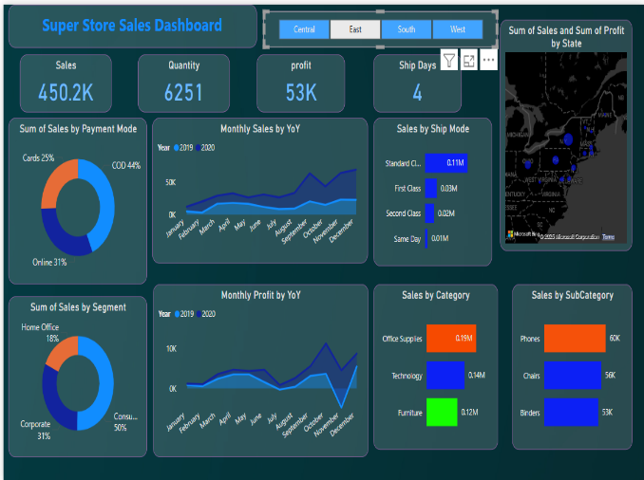 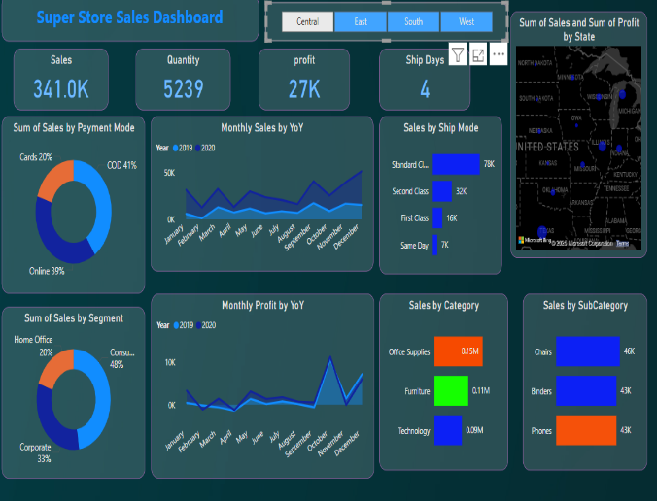

# 

Central Region

* Sales & Category Focus: $341 K total sales (27 K profit), led by Office Supplies (44% share); top states include Illinois, Missouri, and Michigan.
* Payment & Segment Mix: COD (41%) and Online (39%) dominate—opportunity to incentivize card payments to reduce COD-related costs.
* Seasonal Trends: December 2020 saw a big YoY sales spike—recommend Q4 bundles (e.g., Chairs + Binders) and stock high-demand SKUs earlier.

East Region

* Performance & Categories: $450 K sales (53 K profit), with Technology ($140 K) rising behind Office Supplies; strongest states are NY/NJ/PA.
* Payment & B2B: COD (44%) still dominant; test “5% online pre-pay” to shift behaviors; Corporate makes up 31%, so push an “Office Essentials” package to businesses.
* Holiday Surge: Sharp YoY sales and profit jumps in November/December 2020—leverage early-bird Black Friday promos and highlight express shipping for tech bundles

South Region

* Lower Base & Categories: $252 K sales (27 K profit), led by Office Supplies; Phones ($36 K) outpace Chairs/Tables, but overall revenue trails other regions.
* Payment & Segment Opportunity: COD (44%) is high—offer “5% off online pre-pay”; Consumer accounts for 54%, Corporate only 30%—target B2B outreach in TX, FL, GA.
* Mid-Year Lull: Sales dip July–October 2020—run mid-summer/back-to-school promos (e.g., Table + Storage bundles) to smooth out seasonality

West Region

* Top Performer & Balanced Categories: $522 K sales (68 K profit); Office Supplies ($200 K), Technology ($160 K), and Furniture ($160 K) are almost equal—CA is the big driver.
* Corporate & Shipping: Highest Corporate share (35%)—offer volume discounts for businesses; many customers pay for First Class/Same Day, so highlight “Express Ship + Priority Support.”
* Q4 Peak: December 2020 nearly $110 K—a major year-end surge—focus on holiday Tech/Furniture bundles and consider “click-and-collect” for COD shoppers.  
    
  **Central Region – Sales by subcategory**  
  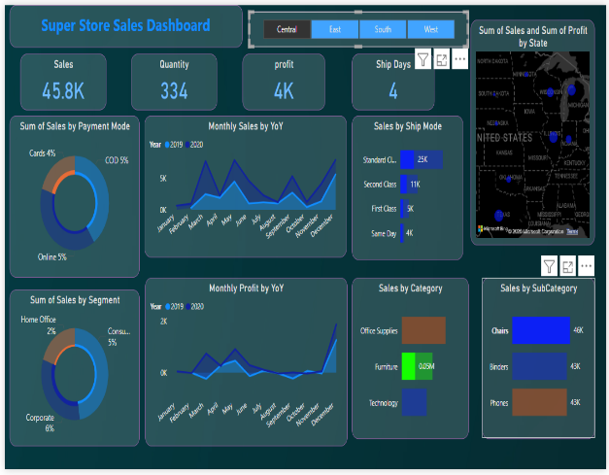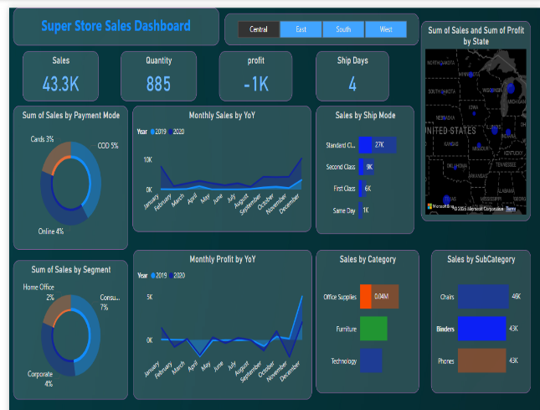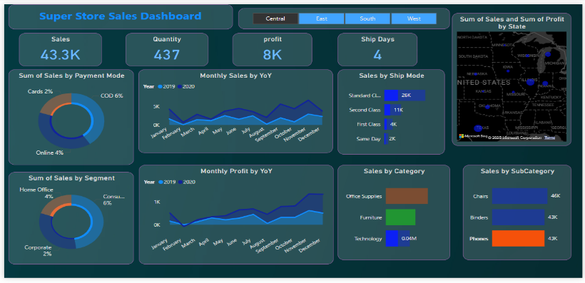

**Chairs** :

* With Chairs at $46 K and both Binders and Phones at $43 K, demand is very balanced. Chairs edge out slightly, suggesting that ergonomic or home-office seating remains a top priority for Central customers.
* Action: Maintain slightly higher inventory levels of your most popular chair models (e.g., mid-priced ergonomic chairs), but avoid overstocking. Since Binders and Phones are within $3 K, keep those SKUs well-stocked too to avoid stockouts.  
    
  **Bundling & Cross-Sell Opportunities:**
* Because Binders and Phones each generate almost the same sales as Chairs, consider pairing them:  
   “Ergonomic Chair + Desk Organizer (Binder)” bundle at a 5% discount.  
   “Desk Chair + Bluetooth Headset (Phone accessory)” cross-sell.
* Bundling can nudge customers who came in for one item to pick up a complementary SKU—raising average order value by $5–$10 per transaction on average.  
    
  **marketing and inventory alignment and seasonality consideration:**Q4 Holiday Bundles & Stock-Up:
* Pre-stock top chairs in October and run a “Holiday Comfort & Organization” bundle—buy a chair, get 50% off a binder—to capitalize on peak demand.

Summer Desk Refresh Promotion:

* In June–July, ensure ample binders and phone accessories inventory, then launch a “Mid-Year Desk Refresh” flash sale bundling phones, binders, and chairs to boost slow-season sales.

State-Targeted Campaigns & Warehousing:

* Coordinate marketing in IL, MO, and MI with warehouse shipments—e.g., October “Fall Office Essentials” (chairs + binders) in Illinois; November “Phone & Seating” sale in Michigan—with stock prepositioned locally.

Dynamic Pricing & Restock Alerts:

* Raise chair prices 5–10% in December while offering binder discounts, and set restock alerts for binders/phone accessories in August to align with “Back-to-Work” promotions.  
    
  **Sum of Sales by Payment Mode** (Cards, COD, Online)  
  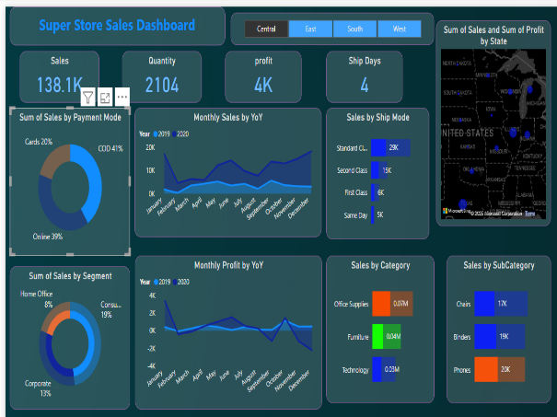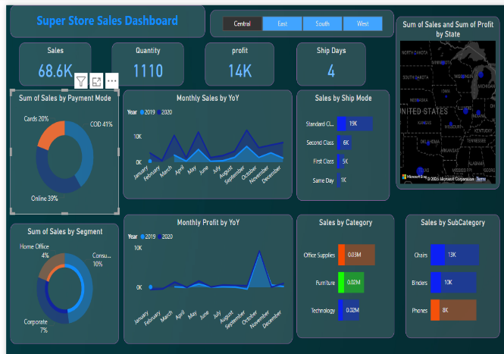  
  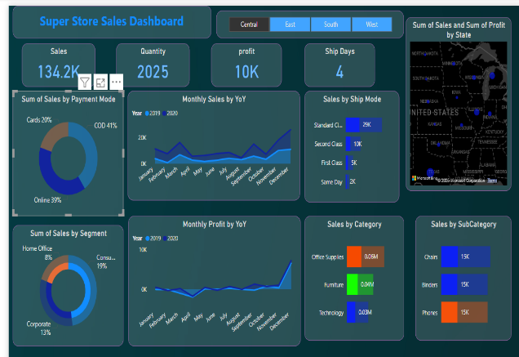  
    
  1. **Online Payments Dominate Sales Share**
* Online payments account for ~39% of all sales across multiple regions.
* This indicates a strong digital adoption — increasing investment in digital infrastructure (e.g., faster checkout, mobile optimization) could boost sales further.  
    
  **2. High COD (Cash on Delivery) Usage Indicates Customer Trust Gap**
* COD consistently makes up ~40-41% of transactions.
* While COD boosts order volume, it often comes with higher risk of returns and logistical costs.
* Consider loyalty incentives or cashback offers for prepaid orders to shift behavior toward more secure methods.  
   **3. Cards Are the Least Used Payment Mode (~20%)**
* Despite widespread access to debit/credit cards, card usage remains low.
* This might reflect payment gateway issues, lack of offers, or customer preference for COD.
* Suggestion: Partner with card providers to launch seasonal discounts or EMI schemes.  
    
  **4.COD Prevalence Could Be Affecting Profit Margins**
* Given COD’s logistical burden (delivery failures, returns), high COD share may be dampening profits, especially in price-sensitive regions.
* Targeting urban areas or tech-savvy segments with prepaid-only offers could help.

**5. Payment Mode Trends Could Predict Regional Behavior**

For example:

* Regions with high online payments may respond better to app-only discounts or wallet partnerships.
* Regions with high COD might require education, trust-building, or improved return policies to transition to digital.  
   **Sum of Sales by Segment** (Home Office, Consumer, Corporate)  
  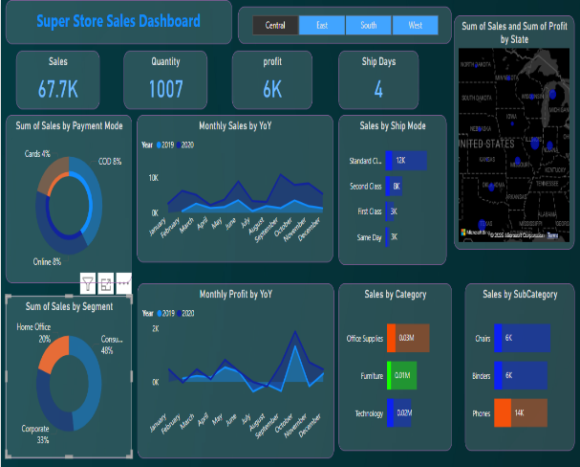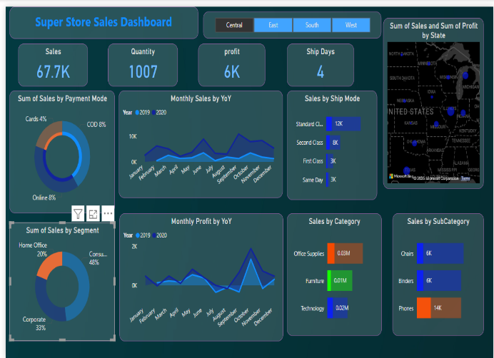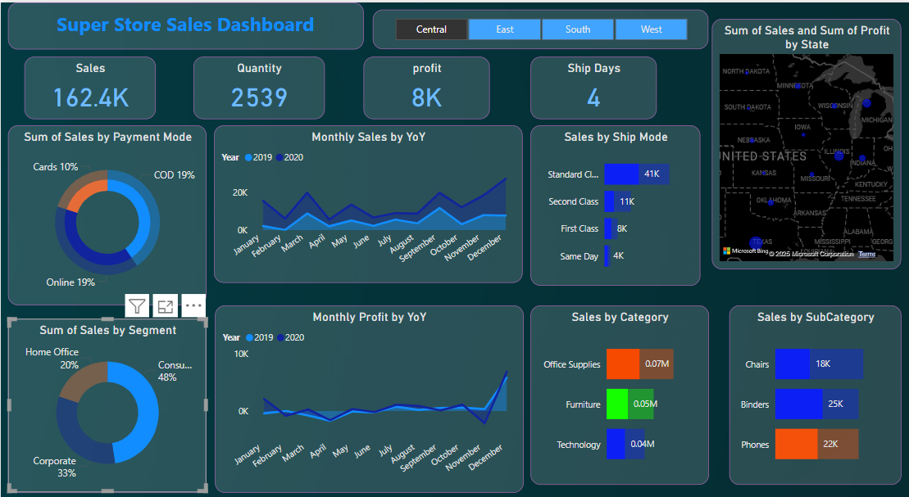  
     
  **Consumer Segment Leads**
* ~48% of total sales consistently come from the Consumer segment.
* This is the most profitable customer base and should be prioritized in promotions and campaigns.

**Corporate Segment is Second**

* Contributes ~33% of sales in most dashboards.
* This segment may yield bulk orders — opportunities for B2B deals or loyalty programs.

**Home Office is the Smallest Segment (~20%)**

* Lower contribution, but potential to grow, especially with remote work trends.
* Consider targeted offers on chairs, desks, or tech bundles.

**Segment Stability Across Regions**

* The percentage distribution remains consistent across different states/regions.
* Suggests broad behavioral trends, not regional anomalies.

**Marketing Focus Suggestion**

* Invest more in retention of Consumers, and growth of Home Office users through educational or productivity-focused campaigns.  
    
  **Sum of Sales by Category (Office Supplies, Furniture, Technology)**  
  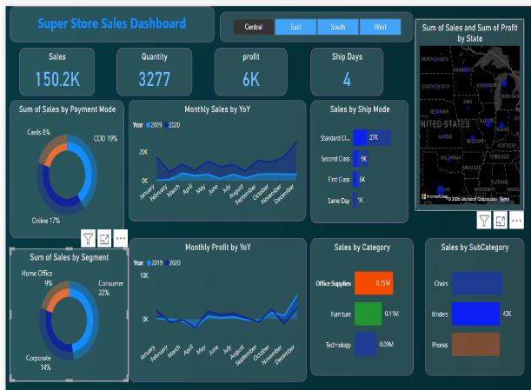 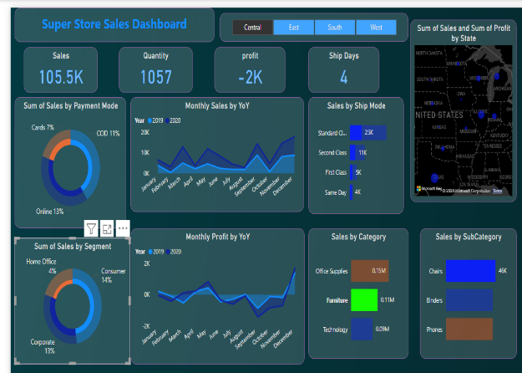

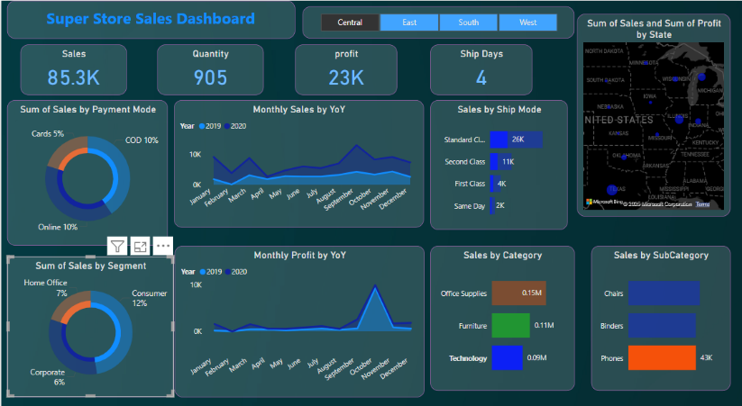  
  
**Office Supplies is the Top Revenue Driver**

* Across all dashboards, Office Supplies consistently contributes ~0.15M in sales.
* Indicates strong demand; consider volume discounts or cross-selling with related products (e.g., tech accessories).  
  **Furniture Holds Strong Mid-Level Sales (~0.11M)**
* Despite fewer units sold, Furniture maintains healthy sales, suggesting higher ticket size per item.  
  Focus marketing on value-based promotions (ergonomics, durability, etc.).  
  **Technology Has the Lowest Sales (~0.09M)**Technology category lags behind others in revenue.Investigate pricing strategy, competition, or customer awareness — this may be an under-tapped segment.  
  **Category Sales Are Consistent Across Dashboards**  
  Little fluctuation in relative sales contribution among categories across different regions/timeframes.  
  Reflects stable customer preferences — optimize inventory planning accordingly.  
  **Opportunity for Growth in Tech Products**With digital adoption growing, tech category has potential.

Suggest offering bundled packages (e.g., laptop + accessories) or promotions targeting remote workers and students.  
  
**Sales by Ship Mode (Standard Class, Second Class, First Class, and Same Day)  
  
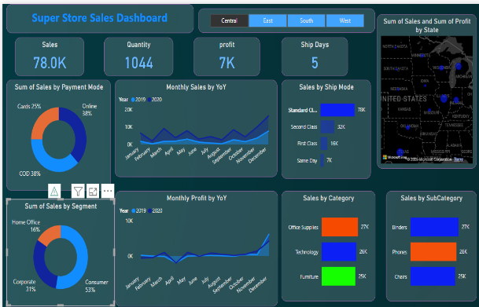 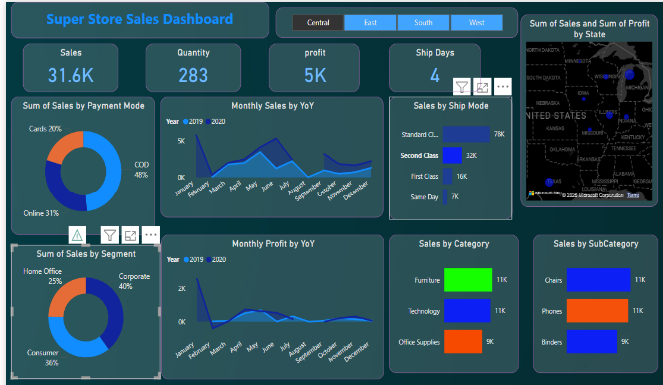**

**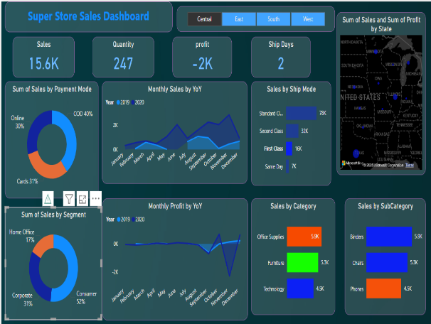 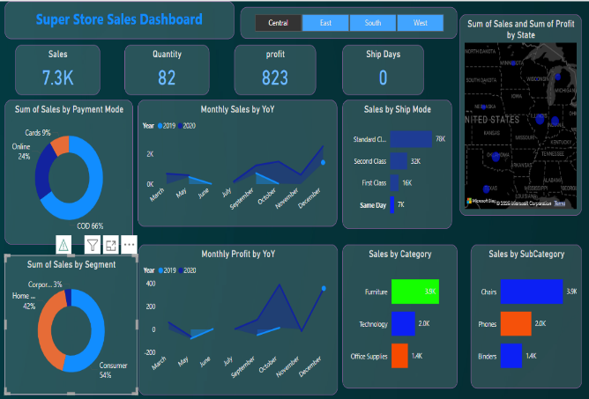  
 Standard Class Dominates Shipping**Standard Class is consistently the highest-used mode, with sales ranging from 24K to 78K.

Suggests customers prioritize cost savings over speed — this mode is likely the most economical**.  
Second Class Is a Strong Secondary Option**Second Class sales are significant (11K to 32K) across dashboards.

Indicates a balanced trade-off between cost and delivery time — could be targeted for mid-value orders or bundled promotions.  
 **First Class Sees Moderate Use**First Class generally has lower sales (4K to 16K) compared to other modes.  
Could be reserved for premium customers or urgent orders, potentially bundled with high-margin products**.  
 Same Day Delivery Has the Lowest Usage**Sales from Same Day mode remain consistently low (0 to 7K).

May be due to higher fees, limited availability, or low perceived value — worth reviewing for optimization or targeted regional rollouts.